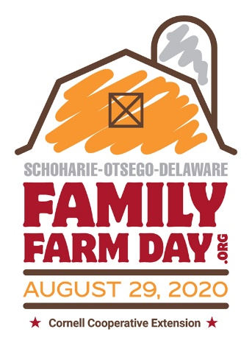
Best Management Practices in Agritourism Events - Family Farm Day
Prepared by Mariane Kiraly, CCE Delaware County

- Provide an authentic farm experience: You become the “face of farming” to your visitors. Create an authentic experience so visitors can understand the realities of agriculture in a meaningful way.
- Offer an educational experience that incorporates learning with a fun or memorable time on the farm. Visitors have very little exposure to real farms that are in business to make a profit by growing food or fiber. Help them understand what it takes.
- Provide excellent customer service: Have enough help for tour day(s); be prepared to offer samples, an experience, or a tour. Be sure to have facilities to wash/clean hands, park easily, sit down and rest.
- Offer a safe and accessible environment where people of all ages can participate. If an event requires climbing onto a wagon, be sure to make easy access to stairs with a rail, and offer a smooth ride. Clear paths so they are free of obstacles and wide enough for a walker. Place signs in areas to warn visitors to stay away, not to touch, or in places that require additional caution. Block off dangerous areas such as ponds, manure pits, or moving machinery.
- Have a First Aid kit handy for minor injuries - bug bites, cuts, or injury.
- Keep frozen food in freezer, cold food on ice, and hot food prepared as needed.
- Be aware of any allergens in food or on the farm. Use appropriate signage to alert visitors and label food properly with all ingredients.
- Be aware of any weather warnings on the day of the tour; plan accordingly with shelters, rain gear, or other equipment to keep guests comfortable and safe.
- Offer ample parking away from areas where activities take place; have signage that shows orderly entry and exit. If a large crowd is expected, assign parking lot attendant to minimize risk of accidents.
- Have fire extinguishers placed in barns, near any outdoor activities where hay or corn mazes are used. Prohibit smoking in those areas.
- Understand the risks of hay rides, rides with tractors or horses, and any activity where guests can slip, trip, or fall. Be sure your insurance carrier knows which activities you are offering and let them help you mitigate risks with these types of activities.
- Be sure that any animals that can be touched have been vaccinated in accordance with “petting zoo” regulations; double fence animals that can bite, kick, or harm visitors to limit access. Always have personnel in the animal area to answer questions and monitor guests.
- If you decide to sell farm products, dedicate a person to handle sales, money, and merchandise. Have an attractive area set up much like a stand at a farmers’ market to enhance the visitor experience. This also reduces confusion, pilferage, or shoplifting of product. Regardless, people have light fingers; put away items not-for-sale and/or of value to you.
- Use these handy checklists for all kinds of agritourism activities!
https://safeagritourism.org/checklists/

